**LAPORAN PROJECT GAME**

**“THUNDER PLANE”**



**Oleh :**

**ALIF FARHA MAULANA**

**A11.2019.12018**

**4502**

**UNIVERSITAS DIAN NUSWANTORO**

**TAHUN 2022/2023**

# **DAFTAR ISI**

**DAFTAR ISI** 2

**BAB I** 3

**TENTANG GAME** 3

**1.** **Deskripsi Game** 3

**2.** **Screen Shot Game** 3

**BAB II** 4

**Detail Pengembangan Aplikasi** 4

**1.** **Flowchart** 4

**2.** **Class Diagram** 5

**3.** **Screen Shot Game** 6

6

Menu Game Thander Plane 6

7

**BAB III** 9

**Referensi** 9

# 

# **BAB I**

## **TENTANG GAME**

1. **Deskripsi Game**

Game Thunder Plane adalah game yang mirip dengan Flapy Bird hanya beda Player Characternya saja selebihnya permainannya sama,tapi tentunya tidak kalah asik dengan flapy Bird.

Cara Bermain game Thunder Plane ini sangatlah mudah dengan ki tap tap saja sama seperti halnya main game Flappy Bird.Di game Thunder Plane ini terdapat juga enemy berupa character berupa Ghost yang nantinya ketika kita menabrak enemy akan gameOver /kembali ke menu awal.Ada yang lebih seru lagi dari game Thunder Plane ini yaitu ketika kita melewati rintangan dan mengambil Koin akan mendapatkan 1 Poin,dan ketika kita mengambil burung akan mendapatkan 2 Poin.Game Thunder Plane ini juga memiliki Multi Level Terdapat Easy,Medium ,dan Hard

1. **Screen Shot Game**

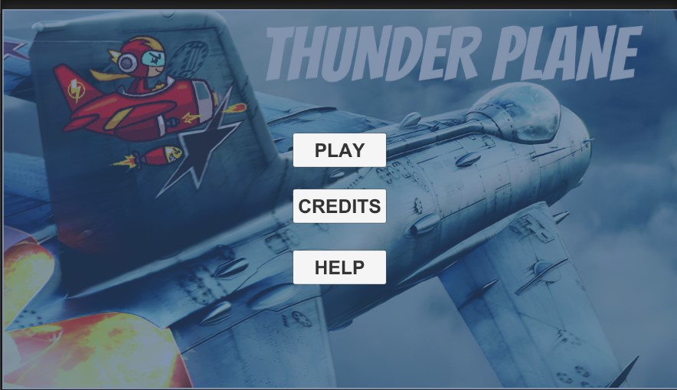

# **BAB III**

## **DETAIL PENGEMBANGAN GAME**

1. Flow Chart

# **BAB II**

# **Detail Pengembangan Aplikasi**

1. **Flowchart**

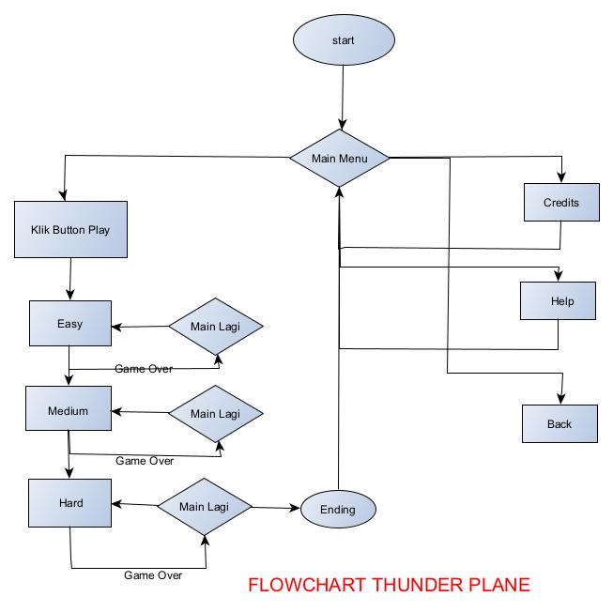

1. **Class Diagram**

|  |
| --- |
| Player Control |
| + jumpForce:Vector  - score:int  + scoreTxt:Text |
| + Update():void  + OnCollisionEnter2D():void  + OnTriggerEnter2D(): void  +score():void  +load():void  +Die():void |

|  |
| --- |
| GUI Manager |
| +bEasy:Button  +bMed:Button  +bHard:Button |
| +Start():void  +LoadLevel():int  +saveLevel():void  +LoadButtonLevel():void  +OnPlay():void  +OnLevel1():void  +OnLevel2():void  +OnLevel3():void |

|  |
| --- |
| Save Load High Score |
| +textHighScore:Text |
| +Start():void  +LoadHighScore():int  +SaveHighScore():void |

|  |
| --- |
| enemy act |
| direction:int  top :int  bottom:int  speed:float |
| +Update():void |

|  |
| --- |
| Generator Obs |
| +rocks: GameObject |
| +Start():void  +CreateObstacle():void |

|  |
| --- |
| Obstacle In Act |
| +veloc:Vector2 |
| +Start():void |

|  |
| --- |
| Music Manager |
| -instance:MusicManager |
| +Instance():MusicManager  +Awake():void |

|  |
| --- |
| GUIback |
| direction:int |
| +Update():void |

|  |
| --- |
| GUIcredits |
|  |
| +Oncredits():void |

|  |
| --- |
| GUIhelp |
|  |
| +Onhelp():void |

1. **Screen Shot Game**



**Menu Game Thander Plane**

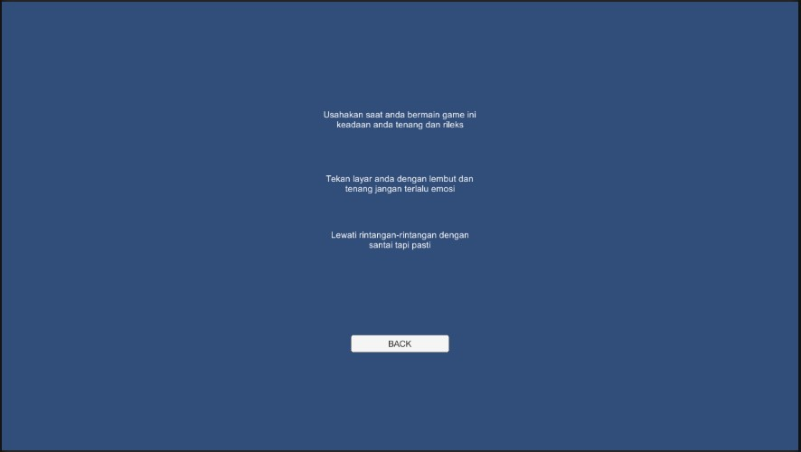

**Credits Game Thander Plane**

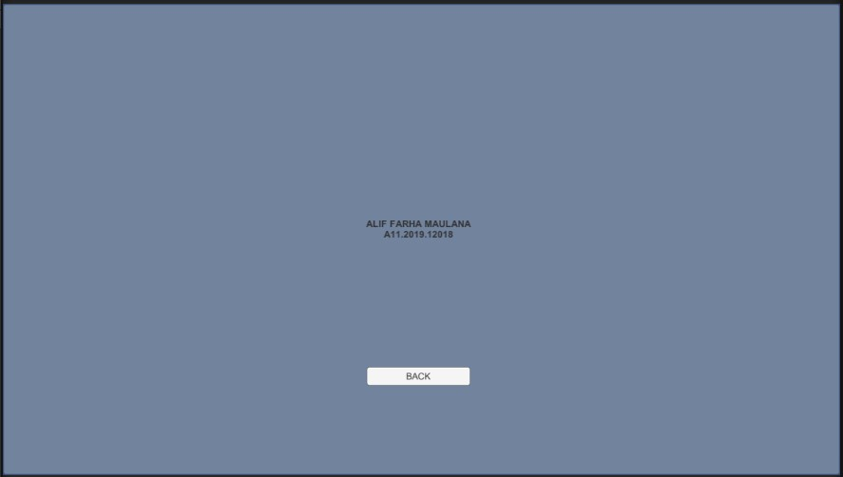

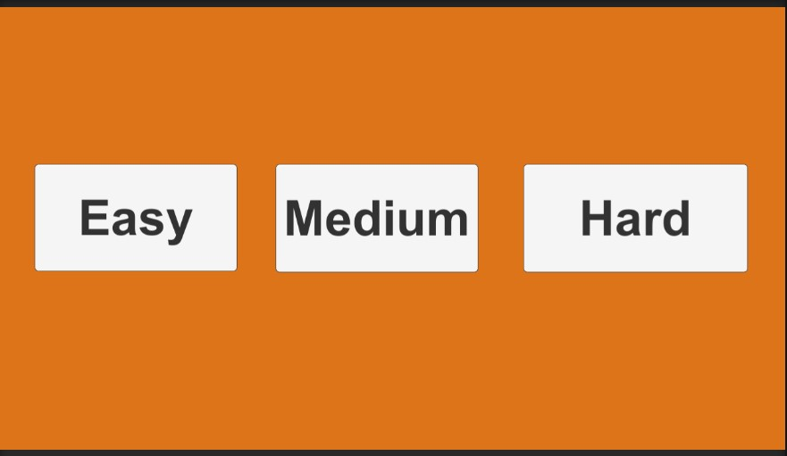 **Help Game Thander Plane**

**Multi Level Game Thander Plane**

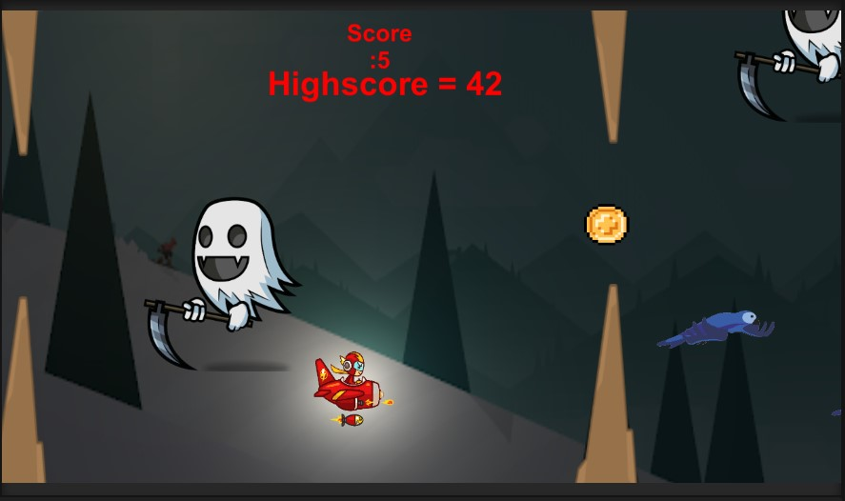

**Game Thander Plane**

# 

# **BAB III**

# **Referensi**

Dalam pengembangan game ini terdapat beberapa referensi dari berbagai sumber, seperti berikut ini:

1. **Player Character**

<https://www.pngwing.com/en/free-png-sbwdv/>

1. **Burung Character**

<https://www.artstation.com/artwork/xzQxZY/>

1. **Enemy Character**

<https://www.pngegg.com/en/png-zedgi/>

1. **Enemy Move Up dan Move Down**

<https://forum.unity.com/threads/help-with-script-making-enemy-move-up-and->down.353603/

1. **Score**

Tutorial GAME PRAKTIKUM 4

1. **HighScore**

Tutorial GAME PRAKTIKUM 9

1. **Main Menu**

Tutorial GAME PRAKTIKUM 9